ABHISHEK ANAND  Land line : 0824-2458233  Mobile No : +91 984-488-5408  Email ID : bobbys0422@yahoo.co.in  bobbys22@gmail.com  Skpye : bobbys0422 | 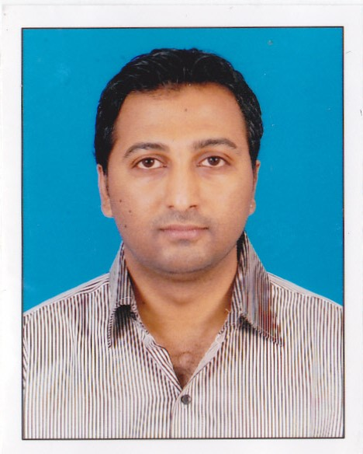

Objective :
To work in an organization whose culture will stimulate creative attitude by utilizing and augmenting my skills, which will add value to organization.

Strengths :
I am a quick learner with a positive attitude and excellent communication skills. Open Mindedness, and a flawless attitude towards feedback provided, evolving to overcome and win the areas of opportunities. Building good rapport with clients, so as to add to the success for the organization.
I have great passion for leading a team, training and mentoring team members.

Work experience :
Total 8+ years of experience in Recruiting & Business Process Outsourcing industry. (Tele Marketing, US mortgage processing and in Quality).

- Blue Bird Technology: Mangalore, July 2013 – Feb 2014
Designation: Team Co-ordinator

- Build and maintain relationships with client contacts and decision makers.
- Ensure client satisfaction through timely delivery, while maintaining quality.
- Ensure timely delivery on mandates.
- Ensure achievement of team target revenues.
- Understanding of the situation and capability to address issues.
- To own and drive and develop the team members for being effective in their role.

- Cognizant Technology Services: Mangalore, Nov 2007 – July 2013
Designation: Voice Specialist/SPE Quality.

Cognizant Technology Solutions Corp. (NASDAQ: CTSH) is an American global provider of custom information technology, consulting and business process outsourcing services. It’s headquartered in Teaneck, New Jersey, United States and is a member of NASDAQ-100, the S&P 500 and Fortune 500. Cognizant has been named to Fortune magazine's 100 Fastest-Growing Companies list for nine consecutive years, including 2011 when it was ranked first in the "All-Stars" list of 16 companies that appear on the fastest-growing list year after year.

Roles and Responsibilities:

- Monitor telephone calls to assess the effectiveness of communications and process parameters.
- To review and audit recorded and live calls and score based on set performance criteria.
- Sampling across multiple processes and clients.
- Providing constructive feedback and review errors with the FTE’s and provide constant oral & documented feedback, help coaching and guidance to improve on the parameters.
- Initiate call listening sessions with onsite RSC team for coaching opportunities and feedback sessions.
- Completion of pre-determined set of call reviews timely, accurately, and completely.
- Preparing and publishing Daily, Weekly, and Monthly Score card and reports.
- Participating in Dashboard Review meetings with process and business owners.
- Contribute ideas and lessons learned to improve training and quality of service.
- To develop and improve domain expertise.
- Actively attending team meetings to understand business priorities and needs.

Achievements at Cognizant:

- Successfully taken part and completed the Six Sigma Yellow belt training.
- Was a kaizen leader and completed two level 2 kaizen on developing and tracking work flow and Agency records & Completion.
- Implemented the “Do not call” programme across the floor. (Visual displays and software)
- Successfully taken quality initiatives and implemented SIPOC and SOP for the Voice and Non voice span.
- Conducted “Written Communication Training”, “First Time Right” and “Website verification” trainings to improve the Quality at work.
- Have been awarded best performer several times and also have achieved the Eagle award.

- Manipal Informatics : Manipal, March, 2006 to Oct, 2007.
Designation: International Tele marketing Executive (ITME)

Manipal informatics [out bound] call centre was the first of its kind in the field of finance control which has achieved a pinnacle of success and had topped the list to start finance BPO in the whole of south Karnataka.

- I have worked has a Mortgage loan officer suggesting repayment and refinancing of existing loans for US customers. (B to C)
- Also worked as a Telemarketer for top companies like AT&T, Verizon and Sprint. (B to B)
- Also had worked in Lead generation and Survey processes.

Roles, Responsibilities and Achievements:

- Met the target on day to day basis.
- Facilitating Process Training to the New joined FTE's.
- Maximum involvement to the team's performance in completion of the tasks put forward by my supervisors.
- Was awarded the best employee of the month consecutively for 4 months and in total 8 times.
- Was the top performer in the process with utmost number of sales and highest percentage of quality.

Educational Qualification:

- MBA from Manipal Sikkim University, 2012 (Specialization-Operations management).
- B.A., Karnataka State Open University, 2010.
- P.U.C., Karnataka State Board, 2005.
- S.S.L.C., St Aloysius high school, Mangalore, 2002.

Technical Skills:

- MS Office ( Excel, Word, PowerPoint, Project)
- Windows operating system ( Windows 7 , 8 , 2000 , Vista)
- MS Outlook
- Remote desktop connection etc.

Personal Details:
Date of Birth : 22/03/1985
Father's Name : Ananda U.
Address : “Shama Anand”
Urwa store, Ashok nagar Rd,
Mangalore: 575006.
Languages Known : English, Hindi Kannada, and Tulu.
Passport # : Z2726016 Valid up to 2023.

